TC-VER-009
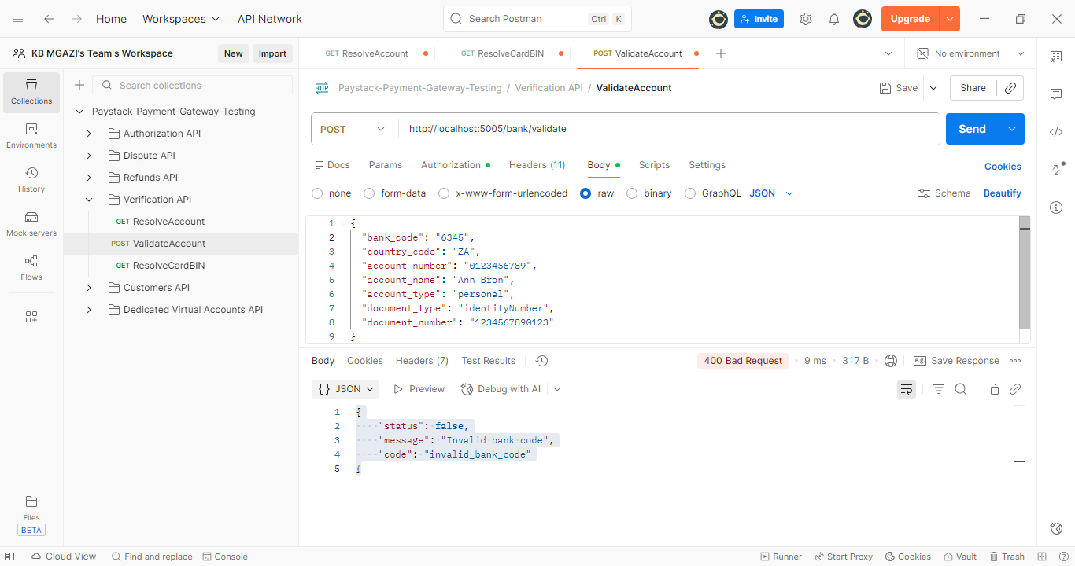
Request:
{
"bank_code": "6345",
"country_code": "ZA",
"account_number": "0123456789",
"account_name": "Ann Bron",
"account_type": "personal",
"document_type": "identityNumber",
"document_number": "1234567890123"
}

Response:
{
"status": false,
"message": "Invalid bank code",
"code": "invalid_bank_code"
}

